**Lab Number: 12 Date: 2025/08/27**

**Title: DNS and Web Server Configuration using Packet Tracer**

**Theory:**

1. **DNS & Web Server**

**DNS (Domain Name System):** DNS is a system that translates human-readable domain names (like google.com) into numeric IP addresses (such as 192.168.1.1) that computers use to communicate. By converting these domain names into IP addresses, DNS simplifies how users navigate the internet, eliminating the need to remember complex numeric addresses. When a user types a domain name into their browser, DNS works in the background to locate the corresponding IP address, allowing the requested web page to be accessed quickly and easily.

**Web Server:** A webserver is a computer system responsible for hosting websites and delivering web pages to users upon request. When a user enters a URL or clicks a link, the web server processes the request, retrieves the appropriate files (such as HTML, images, or scripts), and sends them to the user’s browser. Web servers manage these requests through HTTP or HTTPs protocols. They handle both static content (like basic web pages) and dynamic content generated by server-side application. In short, web servers ensure that web content is available and delivered efficiently to users.

1. 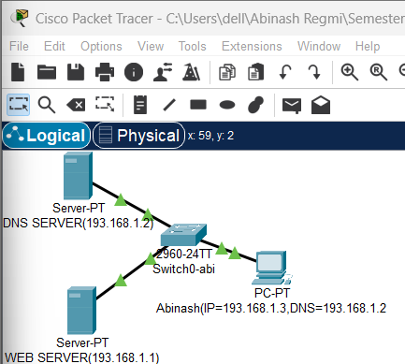**Network Diagram**

Fig: Network Diagram

**Implementation Sequence**

1. **Configuring DNS Server and Web Server**

**DNS Server Configuration:**

**Step 1:** Go to the DNS Server and click on the Desktop tab.

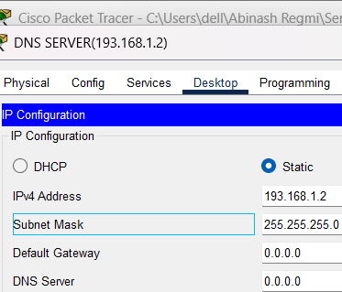**Step 2:** Set the IP Address to 193.168.1.2 and the Subnet Mask to 255.255.255.0

Fig: Configuring DNS server

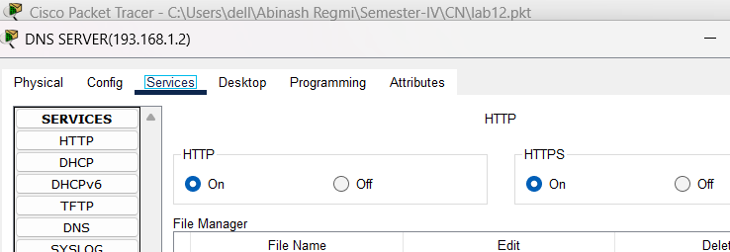**Step 3:** Click on the Services tab, then navigate to HTTP and turn it ON.

Fig: Turning ON HTTP

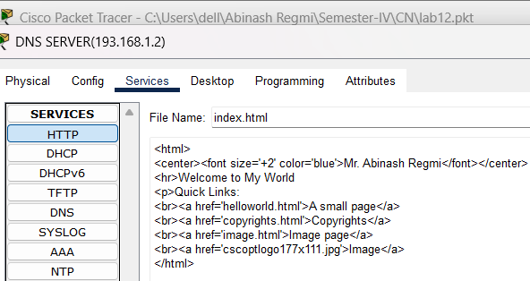**Step 4:** And go to index.html, click edit, make the necessary changes to the file, and click Save.

Fig: Configuring index.html file

**Web Server Configuration:**

**Step 1:** Click on the Web Server, then go to the Config tab.

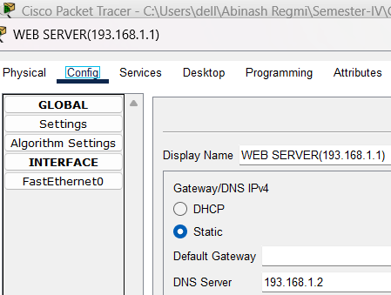**Step 2:** Set the DNS Server to 193.168.1.2

Fig: Configuring DNS on WEB server

**Step 3:** Go to the Desktop tab and set the IP Address to 193.168.1.1, the Subnet Mask to 255.255.255.0, and the DNS Server to 193.168.1.2

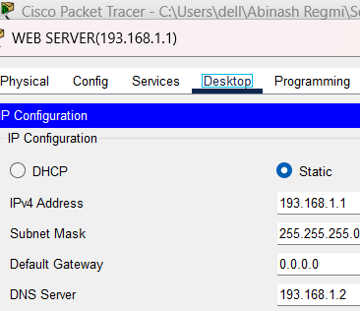

Fig: Configuring WEB server

**PC Configuration:**

**Step 1:** Go to the PC, then navigate to the Desktop tab.

**Step 2:** Set the IP Address to 193.168.1.3, the Subnet Mask to 255.255.255.0, and the DNS Server to 193.168.1.2

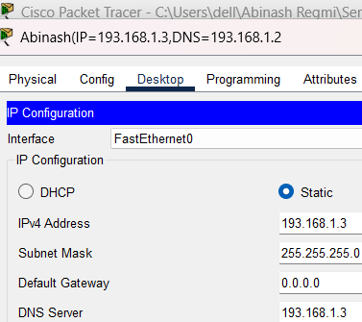

Fig: IP configuration on PC

**Testing Web Server on PC**

**Step 1:** Go to the Desktop, click on Web Browser, and in the URL tab, enter the IP address of the Web Server, i.e., 193.168.1.1

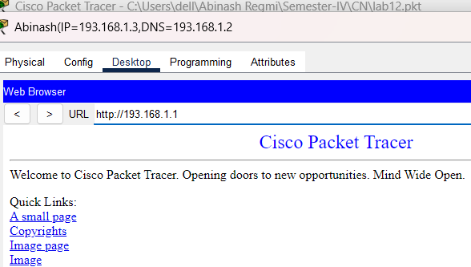

Fig: Checking WEB server on PC

**Web Server in DNS Server Configuration**

**Step 1:** Go to the DNS Server then click on Services, then select DNS.

**Step 2:** In the Name field, type google.com, enter the IP address of the Web Server in Address field, i.e. 193.168.1.1 then click add and then save.

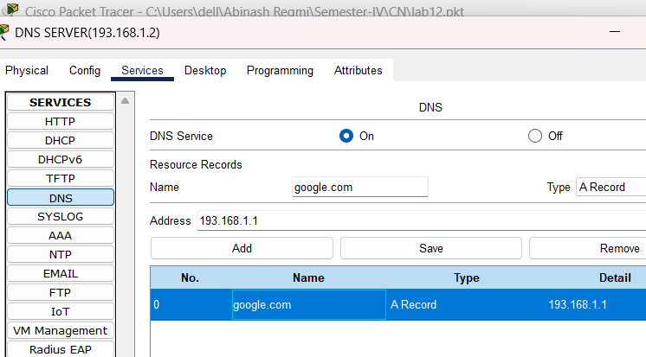

Fig: Adding WEB server on DNS server

**Testing Web Server on PC after configuring in DNS**

**Step 1:** Go to the Desktop, click on Web Browser, and in the URL tab, type google.com to access the webpage served by the Web Server.

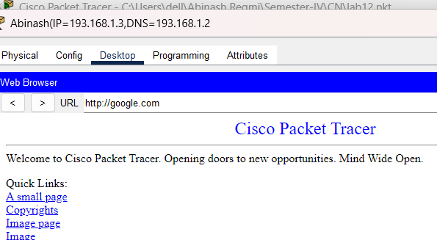

Fig: Checking Web Server after configuration in DNS

From above picture, we can verify that whether we type Name or IP address we will get the same web page.

**Conclusion**

In this lab, we demonstrate how DNS simplifies the process of accessing web services by resolving human-readable domain names into machine-friendly IP addresses. The configuration in Packet Tracer illustrates how DNS and web servers can be set up and function together within a network, making it easier for users to access web resources using familiar domain names.